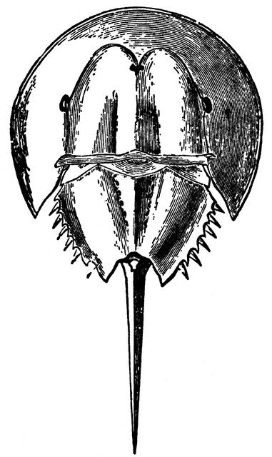
E.S. Rhodes PTA

February 4, 2019

- Welcome! Introductions
- Calendar of Events
- Winter Dance (2/8)
- 5K Planning Meeting
- Treasurer Report
- Other Updates
  - Teacher Feedback/Grants/Field trips
  - Volunteer sign ups - update
  - Garden and mentor update - seeds
  - Barrows PTO communication
  - PTO/PTA district -wide sharing event

- Principal’s Update
- Open Questions / Input

President: Karen Stewart  kpositive11@gmail.com | Vice-President: Angie Howard-McParland  ahowardmcparland@gmail.com
Recording Secretary: Natalina Earls  natalinaearls1123@gmail.com | Corresponding Secretary: Julia Vaca  juliapvaca@gmail.com
Treasurer: Courtney Croke  court317@gmail.com | Membership: Nikki Gilbert  nashleygilbert@gmail.com

